**Study of Continuous-Time Signal using MATLAB**

**Lab # 03**



**Fall 2023**

**CSE-402L Digital Signal Processing Lab**

Submitted by: **Ali Asghar**

Registration No.: **21PWCSE2059**

Class Section: **C**

“On my honor, as student of University of Engineering and Technology, I have neither given nor received unauthorized assistance on this academic work.”

Submitted to:

**Dr. Yasir Saleem Afridi**

Date:

**16th October 2023**

**Department of Computer Systems Engineering**

**University of Engineering and Technology, Peshawar**

1. Unit Sample sequence

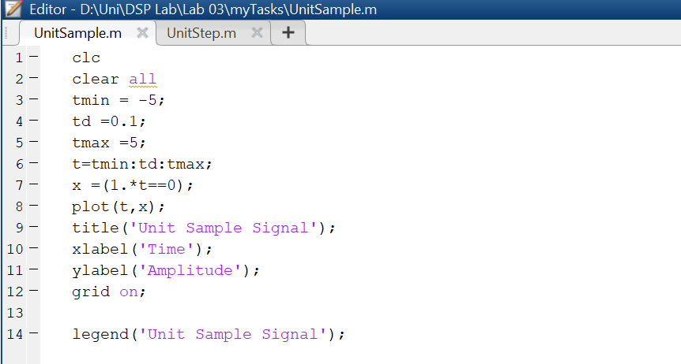

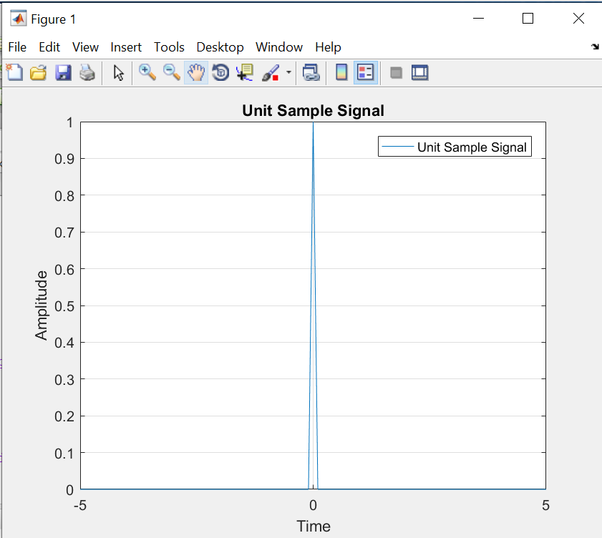

The **unit sample signal**, often denoted as δ[t] (or δ[n] for discrete-time) in discrete-time signal processing, is a fundamental signal with certain characteristics. Here are the characteristics of a unit sample signal:

**Definition:**

The unit sample signal (for discrete-time), denoted as δ[n], is defined as

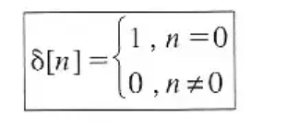

For continuous-time, just replace n by t.

**Amplitude:**

The amplitude of the unit sample signal is 1 at the time index where the signal is non-zero (i.e., at n = 0).

**Impulse Property:**

The unit sample signal is often referred to as an impulse or delta function because it has a peak value at n = 0 and is zero elsewhere.

**Uses in System Analysis:**

The unit sample signal is often used in system analysis and is crucial in understanding the response of systems to impulses.

If we give unit impulse as input to a system, then we get the transfer function of a system as response. Hence, we recognize the behavior of the system and we can predict its output easily. This phenomenon is referred to as “Impulse Response of a System.”

1. Unit Step Signal

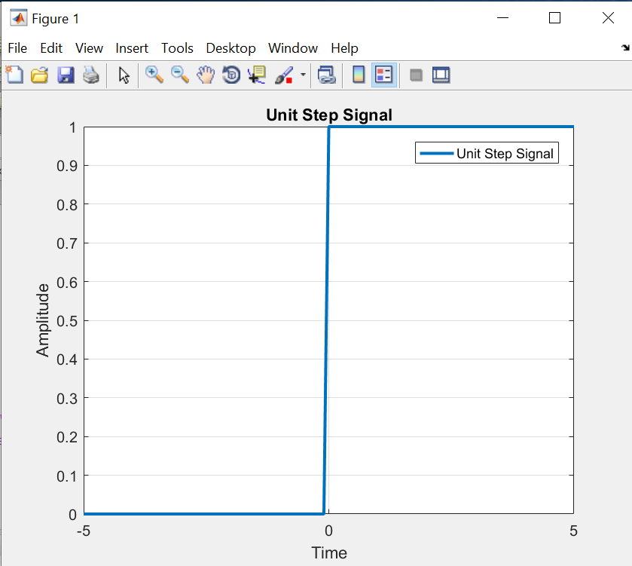

**Definition:**

The unit step signal, u(t), is defined as:

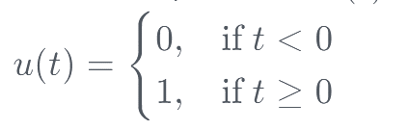

**Amplitude:**

The amplitude of the unit step signal is 0 for t < 0 and 1 for t >= 0.

**Step at t = 0:**

There is a step change in amplitude at t = 0, going from 0 to 1.

**Discontinuity:**

The unit step signal has a discontinuity at t = 0 since its value changes abruptly at this point.

**Applications:**

The unit step signal is widely used in signal processing and control systems to model sudden changes or transitions in a system.

In summary, the continuous-time unit step signal is a foundational signal with a step change in amplitude at t = 0. It is used to model situations where a system undergoes an abrupt change or starts at a specific time.

1. Ramp Signal

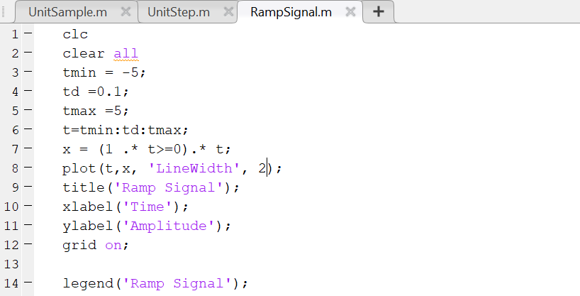

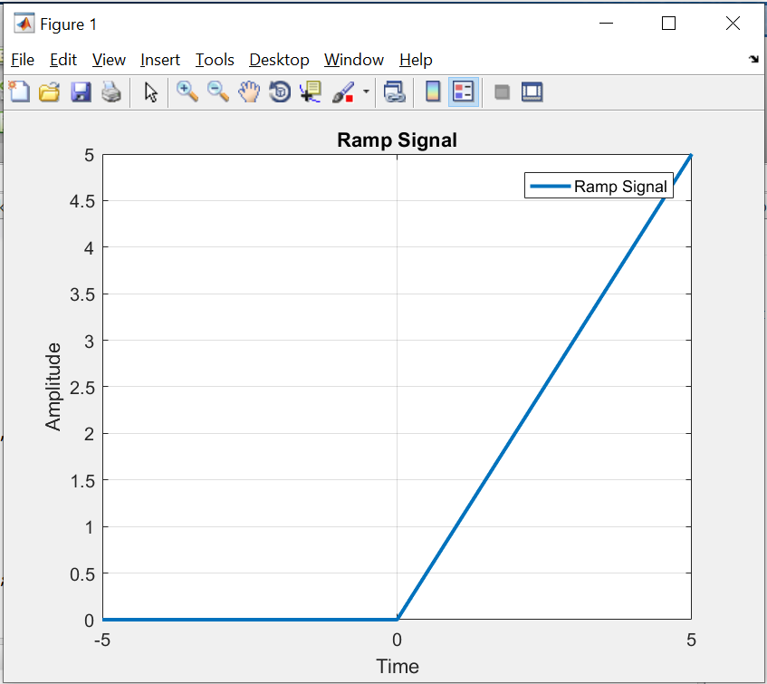

**Definition:**

The ramp signal, r(t) is defined as:

**Amplitude:**

The amplitude of the ramp signal is 0 for t < 0 and increases linearly with time for

t > 0.

**Linear Increase:**

The signal exhibits a linear increase in amplitude with time, starting from 0 at t = 0.

**Applications:**

The ramp signal is commonly used in engineering and physics to model linearly increasing quantities, such as the position of an object moving with constant velocity.

In summary, the continuous-time ramp signal is characterized by a linear increase in amplitude with time, starting from zero at t = 0. It is a useful signal in modeling systems with continuous and steady changes over time.

1. Parabolic Signal

**Definition:**

The parabolic signal p(t), is defined as:

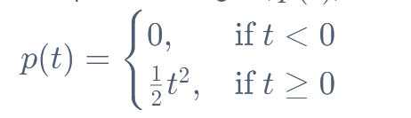

**Amplitude:**

The amplitude of the parabolic signal increases quadratically with time t.

**Quadratic Increase:**

The signal exhibits a quadratic increase in amplitude with time, starting from 0 at

t = 0.

**Applications:**

Parabolic signals are often used in physics and engineering to model quantities that vary with the square of time, such as the position of an object under constant acceleration.

In summary, the continuous-time parabolic signal is characterized by a quadratic increase in amplitude with time, starting from zero at t = 0. It is a useful signal in modeling systems with acceleration or other processes that exhibit a quadratic relationship with time.

1. Sinusoidal Signal

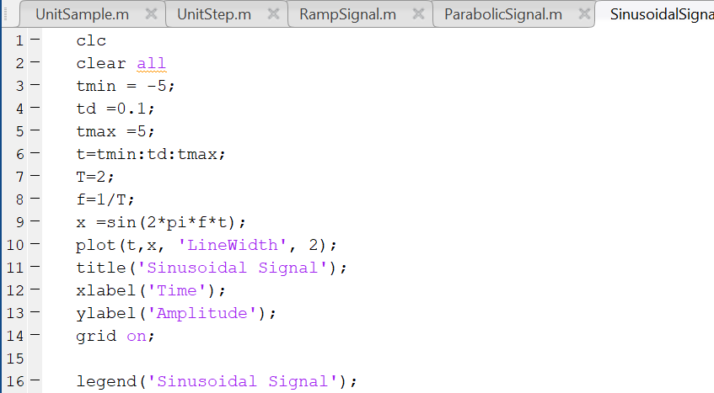

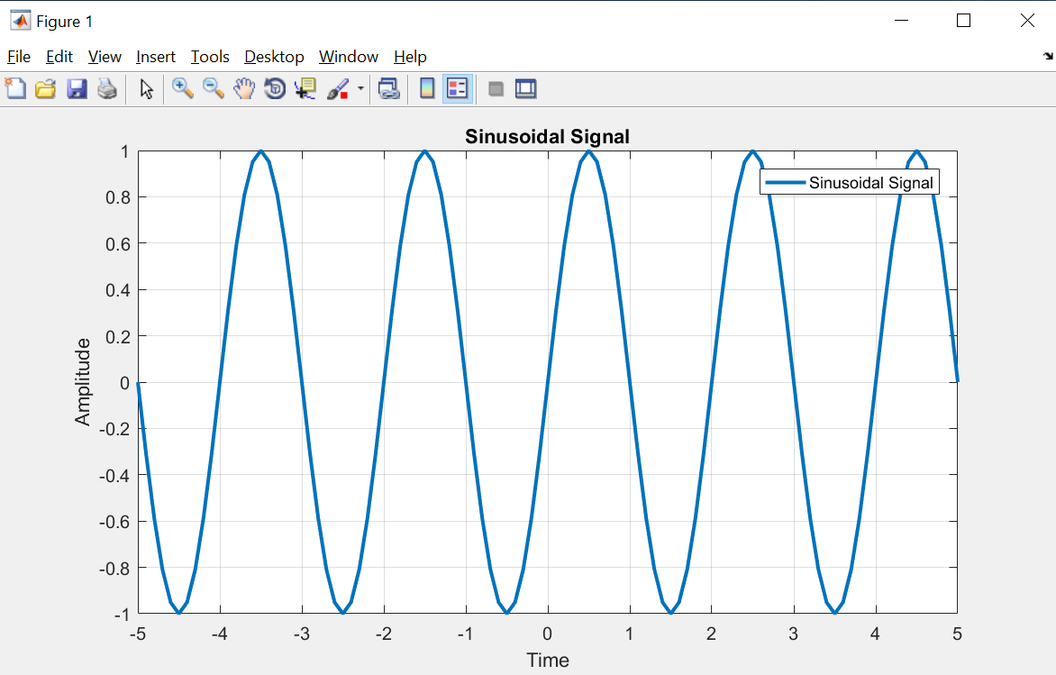

**Definition:**

The sinusoidal signal x(t) is defined as:

$x\left(t\right)=A.cos\left(2πft+φ\right)$

*or*

$$x\left(t\right)=A.sin\left(2πft+φ\right)$$

where:

* **A** is the amplitude,
* **f** is the frequency in hertz (cycles per second),
* **t** is time,
* $φ$ is the phase angle.

**Amplitude and Frequency:**

Amplitude A represents the maximum value of the signal. The frequency f is the number of cycles per unit of time.

**Time Period:**

Time Period T is the time taken to complete one full cycle. It is inversely proportional to the frequency.

**Phase:**

The phase $φ$ represents a horizontal shift (in radians) of the sinusoidal wave. A positive phase shift represents a delay, while a negative phase shift represents an advance.

**Applications:**

Sinusoidal signals are prevalent in various fields, such as communication, audio processing, and physics. They are fundamental in describing oscillatory behavior.

In summary, the continuous-time sinusoidal signal is a periodic waveform characterized by amplitude, frequency, and phase. Its mathematical elegance and widespread occurrence make it a fundamental building block in signal processing and system analysis.

1. Triangular Signal

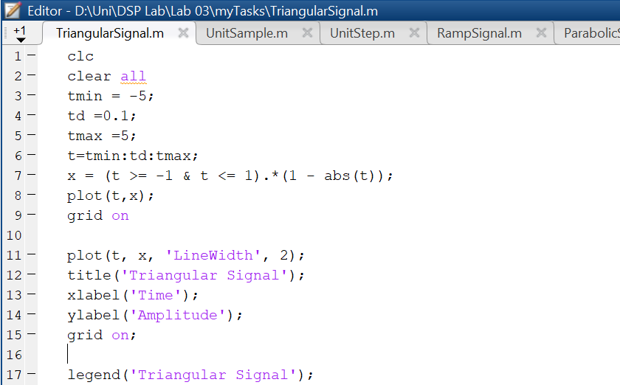

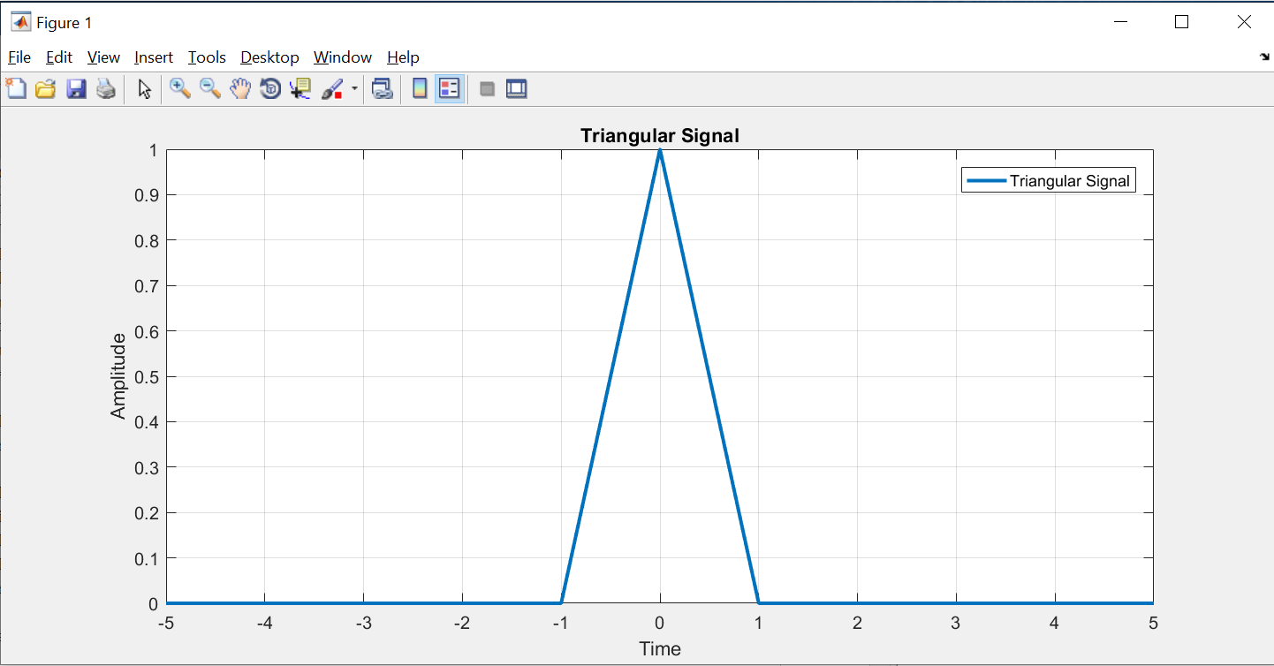

**Definition:**

The unit triangular signal, (t), is defined as:

$$x\left(\frac{t}{τ}\right)=1-\frac{\left|t\right|}{τ} for \left|t\right|<τ$$

$$x\left(\frac{t}{τ}\right)=0 for \left|t\right|>τ$$

**Symmetry:**

The unit triangular impulse signal is symmetric about the time axis.

**Applications:**

The unit triangular impulse signal is often used in signal processing and system analysis, especially in cases where a triangular pulse with unit area is needed.

In summary, the unit triangular impulse signal is a normalized version of the triangular pulse, where the area under the pulse is equal to 1. It is a useful signal in various applications, particularly in scenarios where a standardized triangular pulse is required for mathematical convenience.

1. Signum Signal

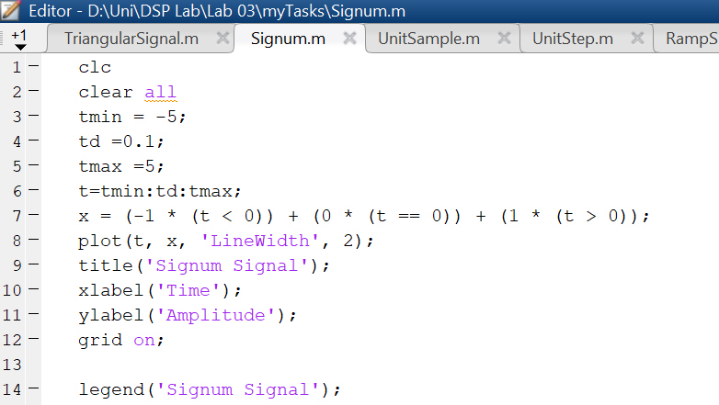

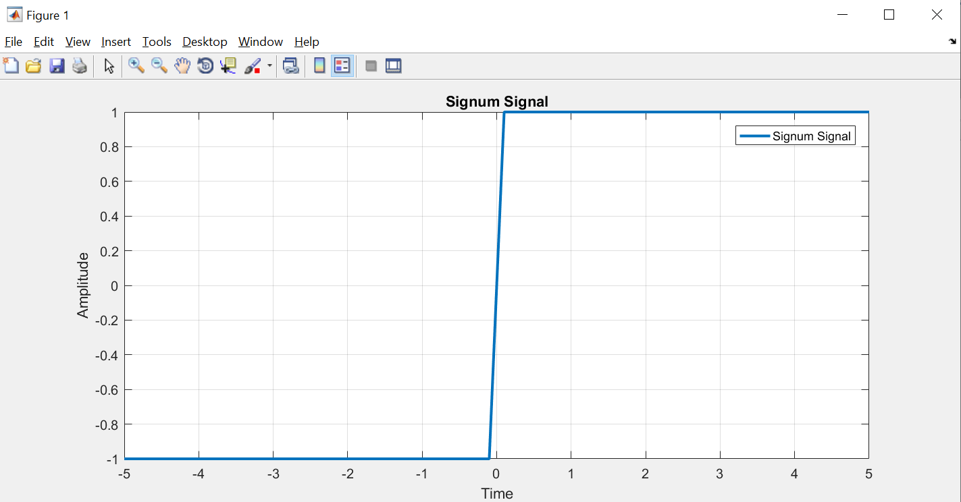

**Definition:**

The signum signal, denoted as *sgn(t)*, is defined as:

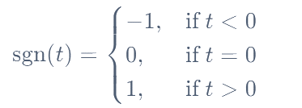

**Amplitude:**

The amplitude of the signum signal is always 1.

**Applications:**

The signum signal is commonly used in mathematics, engineering, and signal processing. It is used to extract the sign of a quantity and is part of various mathematical tools. In signal processing, the signum function is employed for tasks such as feature extraction, where the direction of change in a signal is important. It is also used in thresholding and quantization operations. In communication systems, the signum signal is used for phase detection and modulation schemes. It plays a role in extracting information about the phase or direction of a signal.

In summary, the signum signal is a mathematical function that provides information about the sign of a real number. It is used in various mathematical and engineering applications, particularly in cases where the sign of a quantity is important.

1. Sinc Signal

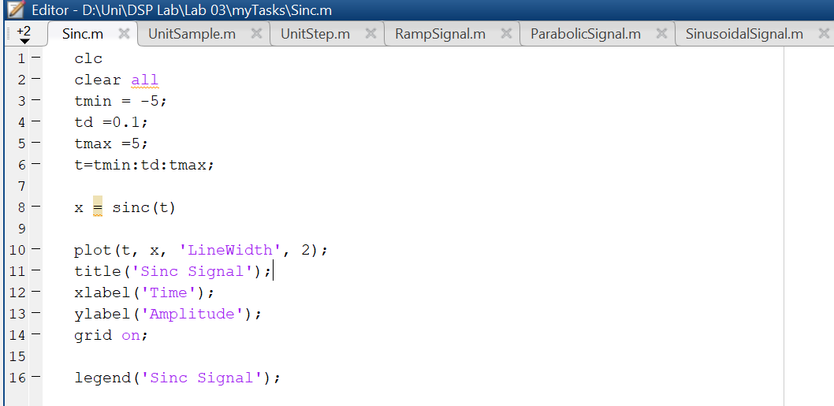

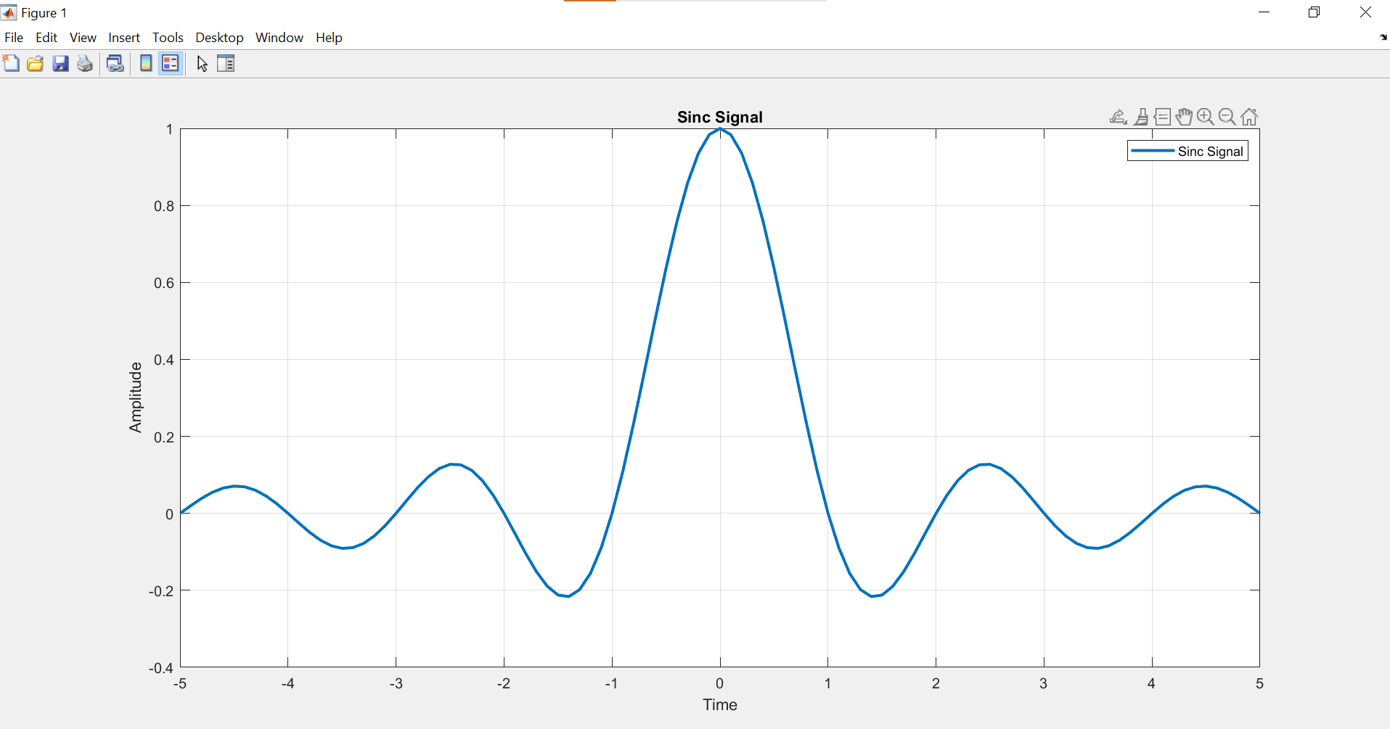

**Definition:**

The sinc signal is defined as the sine of a normalized frequency divided by the normalized frequency.

**Main Lobe:**

The main lobe of the sinc signal is the central region around the origin where the function has positive values.

**Side Lobes:**

The sinc signal exhibits side lobes, which are oscillations on either side of the main lobe. The amplitude of the side lobes decreases as the distance from the main lobe increases.

**Fourier Transform:**

The sinc signal is the Inverse Fourier transform of a rectangular pulse in the frequency domain.

**Applications:**

The sinc signal is crucial in filter design, especially in the design of low-pass filters. The ideal low-pass filter impulse response is represented by a sinc. The sinc signal plays a fundamental role in sampling theory. The sinc is the theoretical impulse response of an ideal low-pass filter, and the sinc interpolation formula is used in reconstructing a continuous signal from its samples.

In communication systems, the sinc is used in the design of pulse shaping filters for minimizing intersymbol interference.

The sinc signal has widespread applications in signal processing, communications, filter design, and other areas of engineering and mathematics. Its properties make it a valuable tool for understanding and manipulating signals in different domains.